Installasi Apache Doris on Ubuntu

Software and Hardware Requirements
Ensure your system meets the following requirements :
- Ubuntu 16.04 and above.
- JAVA 1.8 and above.
- GCC 4.8.2 and above.
- Python 2.7 and above
- Apache Maven 3.5 and above
- CMake 3.19.2 and above
- ext4 and xfs file systems.
- CPU 8cores.
- 8 GiB memory
- Disable the swap partition
- Stable internet connectivity.

Ensure your system meets the requirements. Check the version of your system by the neofetch command.
$ sudo apt install neofetch
$ neofetch
The output of the command:
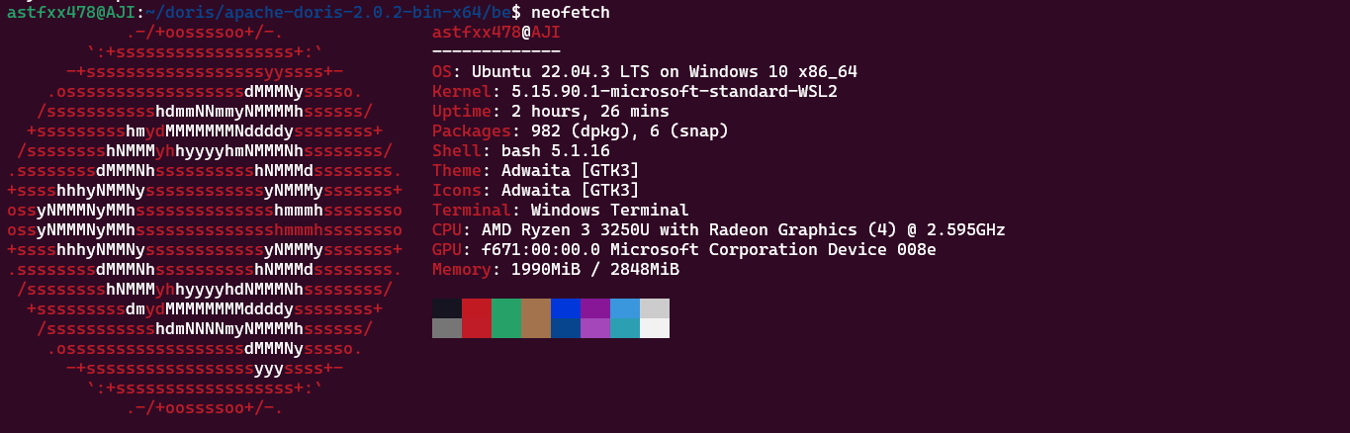My hardware does not support in this case, so I use telkomsel server as an example for this documentation.
Next, update and upgrade your system to refresh your APT cache index.
$sudo apt update && sudo apt upgrade
Once the update is done, disable the swap partition.
$sudo swapoff -a

Step 1: Install the required dependencies.
$ sudo apt install build-essential maven cmake byacc flex automake libtool-bin bison binutils-dev libiberty-dev zip unzip libncurses5-dev curl git ninja-build
$ sudo apt install python3
$ sudo apt install default-jre
$ sudo apt install default-jdk
cek version jdk and jre
$javac –version
javac 11.0.20.1
javac 11.0.20.1
$ java –version
openjdk 11.0.20.1 2023-08-24
OpenJDK Runtime Environment (build 11.0.20.1+1-post-Ubuntu-0ubuntu122.04)
OpenJDK 64-Bit Server VM (build 11.0.20.1+1-post-Ubuntu-0ubuntu122.04, mixed mode, sharing)

Next thing is to set the JAVA_HOME environment variable. This is to make JAVA available system-wide as well as specify the JAVA location in the system. Begin by checking the installation location of JAVA by this command below.

$ sudo update-alternatives --config java
There is only one alternative in link group java (providing /usr/bin/java): /usr/lib/jvm/java-11-openjdk-amd64/bin/java
Nothing to configure.

#Your output might look like this.
There are 2 choices for the alternative java (providing /usr/bin/java).

Selection Path Priority Status
------------------------------------------------------------
0 /usr/lib/jvm/java-11-openjdk-amd64/bin/java 1111 auto mode
1 /usr/lib/jvm/java-11-openjdk-amd64/bin/java 1111 manual mode
* 2 /usr/lib/jvm/java-11-oracle/bin/java 1091 manual mode

Press <enter> to keep the current choice[*], or type selection number:

Configure the Java environment using your preferred text editor. Edit the file below.
$ sudo vim /etc/environment
# Add the following line.
JAVA_HOME="/usr/lib/jvm/java-11-openjdk-amd64"
Then save file
Verify that the environment variable is set:
$ echo $JAVA_HOME
/usr/lib/jvm/java-11-openjdk-amd64
Karena di server Telkomsel tidak bisa install gcc dan g++, jadi saya menggunakan ssh untuk mengcopy file gcc dan g++
Di server ubuntu local saya download gcc dan g++
$ sudo apt install gcc-11 g++-11
Lalu kita copy file ke server Telkomsel
$ sudo scp nama file user@10.54.18.188:home/user/contoh/
Disini sebagai contoh saya mengcopy file dari server local ke server Telkomsel dengan keterangan sebagai berikut
Nama file = adalah file yang ingin kalian copy ke server tujuan disini saya mengcopy file (gcc-11_11.4.0-2ubuntu1~20.04_amd64.deb, libgcc-11-dev_11.4.0-2ubuntu1~20.04_amd64.deb, g++-11_11.4.0-2ubuntu1~20.04_amd64.deb dan libstdc++-11-dev_11.4.0-2ubuntu1~20.04_amd64.deb)
user@10.54.18.188 adalah user = pemilik file di server tujuan dan ip adalah Alamat ip server tujuan
:home/user/contoh = adalah lokasi tujuan file copy tersebut

Jika Sudah kita dpkg -i
$ sudo dpkg -i gcc-11_11.4.0-2ubuntu1~20.04_amd64.deb libgcc-11-dev_11.4.0-2ubuntu1~20.04_amd64.deb
$ sudo dpkg -i g++-11_11.4.0-2ubuntu1~20.04_amd64.deb libstdc++-11-dev_11.4.0-2ubuntu1~20.04_amd64.deb

Lalu install file apache dorisny melalu website resmi :
https://doris.apache.org/download/
Disini kita bisa mengcustom cpu model, version, dan downloadny sebagai binary/source
dan disini saya mendownload lagi melalui local lalu baru di copy ke server telkomsel
dengan keterangan file download
version : 2.0.2 (latest)
cpu model : avx2
download : binary
$ sudo wget https://apache-doris-releases.oss-accelerate.aliyuncs.com/apache-doris-2.0.2-bin-x64.tar.gz
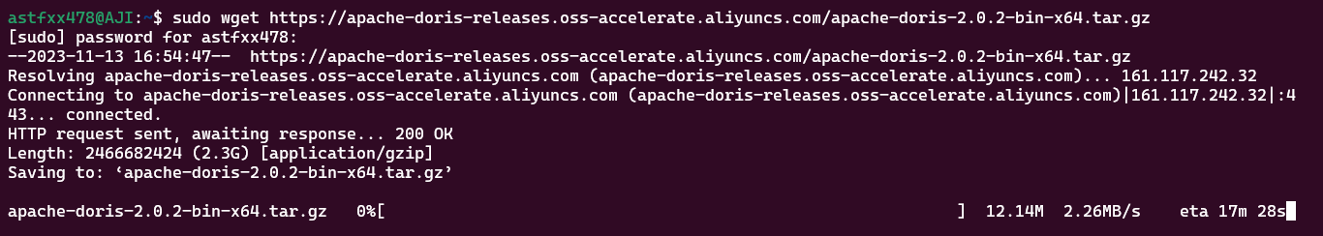
Lalu scp lagi ke server Telkomsel
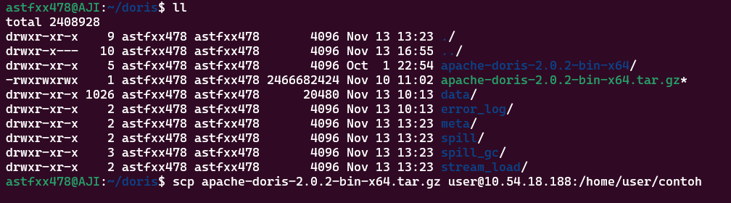
Jika file tersebut sudah ada di server telkomsel kita bisa langsung mengekstrak file tersebut
$ sudo tar xf apache-doris-2.0.2-bin-x64.tar.gz
Jika Sudah di dalam file tersebut akan ada folder be dan fe

Step 2: Set up Fe.
Buka file configurast fe
$ cd apache-doris-2.0.2-bin-x64/fe/
$ nano conf/fe,conf
ubah seperti ini :
# Licensed to the Apache Software Foundation (ASF) under one
# or more contributor license agreements. See the NOTICE file
# distributed with this work for additional information
# regarding copyright ownership. The ASF licenses this file
# to you under the Apache License, Version 2.0 (the
# "License"); you may not use this file except in compliance
# with the License. You may obtain a copy of the License at
#
# http://www.apache.org/licenses/LICENSE-2.0
#
# Unless required by applicable law or agreed to in writing,
# software distributed under the License is distributed on an
# "AS IS" BASIS, WITHOUT WARRANTIES OR CONDITIONS OF ANY
# KIND, either express or implied. See the License for the
# specific language governing permissions and limitations
# under the License.

#####################################################################
## The uppercase properties are read and exported by bin/start_fe.sh.
## To see all Frontend configurations,
## see fe/src/org/apache/doris/common/Config.java
#####################################################################

CUR_DATE=`date +%Y%m%d-%H%M%S`

# the output dir of stderr and stdout
LOG_DIR = ${DORIS_HOME}/log

JAVA_OPTS="-Djavax.security.auth.useSubjectCredsOnly=false -Xss4m -Xmx8192m -XX:+UseMembar -XX:SurvivorRatio=8 -XX:MaxTenuringThreshold=7 -XX:+PrintGCDa>
# For jdk 9+, this JAVA_OPTS will be used as default JVM options
JAVA_OPTS_FOR_JDK_9="-Djavax.security.auth.useSubjectCredsOnly=false -Xss4m -Xmx8192m -XX:SurvivorRatio=8 -XX:MaxTenuringThreshold=7 -XX:+CMSClassUnload>
##
## the lowercase properties are read by main program.
##

# INFO, WARN, ERROR, FATAL
sys_log_level = INFO

# NORMAL, BRIEF, ASYNC
sys_log_mode = NORMAL

# store metadata, must be created before start FE.
# Default value is ${DORIS_HOME}/doris-meta
meta_dir = ${DORIS_HOME}/doris-meta (buka command)

# Default dirs to put jdbc drivers,default value is ${DORIS_HOME}/jdbc_drivers
# jdbc_drivers_dir = ${DORIS_HOME}/jdbc_drivers

http_port = 8030
rpc_port = 9020
query_port = 9030
edit_log_port = 9010

# Choose one if there are more than one ip except loopback address.
# Note that there should at most one ip match this list.
# If no ip match this rule, will choose one randomly.
# use CIDR format, e.g. 10.10.10.0/24 or IP format, e.g. 10.10.10.1
# Default value is empty.
priority_networks = 10.54.18.0/24 (sesuaikan dengan Alamat ip anda)

# Advanced configurations
# log_roll_size_mb = 1024
# sys_log_dir = ${DORIS_HOME}/log
# sys_log_roll_num = 10
# sys_log_verbose_modules = org.apache.doris
# audit_log_dir = ${DORIS_HOME}/log
# audit_log_modules = slow_query, query
# audit_log_roll_num = 10
# meta_delay_toleration_second = 10
# qe_max_connection = 1024
# qe_query_timeout_second = 300
# qe_slow_log_ms = 5000
Lalu save
Jika sudah di save jalankan fe apache dorisnya
$./bin/start_fe.sh –daemon (-- daemon agar dia tidak stop)
lalu cek dengan netstat -pltun
$ netstat -pltun
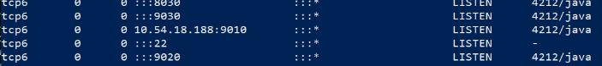
Step 3: Set up Be.
$ cd ../be/
open konfigurasi be
$ nano conf/be.conf
ubah seperti ini :
Step 2: Set up Fe.# Licensed to the Apache Software Foundation (ASF) under one
# or more contributor license agreements. See the NOTICE file
# distributed with this work for additional information
# regarding copyright ownership. The ASF licenses this file
# to you under the Apache License, Version 2.0 (the
# "License"); you may not use this file except in compliance
# with the License. You may obtain a copy of the License at
#
# http://www.apache.org/licenses/LICENSE-2.0
#
# Unless required by applicable law or agreed to in writing,
# software distributed under the License is distributed on an
# "AS IS" BASIS, WITHOUT WARRANTIES OR CONDITIONS OF ANY
# KIND, either express or implied. See the License for the
# specific language governing permissions and limitations
# under the License.

CUR_DATE=`date +%Y%m%d-%H%M%S`

PPROF_TMPDIR="$DORIS_HOME/log/"

JAVA_OPTS="-Xmx1024m -DlogPath=$DORIS_HOME/log/jni.log -Xloggc:$DORIS_HOME/log/be.gc.log.$CUR_DATE -Djavax.security.auth.useSubjectCredsOnly=false -Dsun.java.command=DorisBE -XX:-CriticalJNINatives -DJDBC_MIN_POOL=1 -DJDBC_MAX>
# For jdk 9+, this JAVA_OPTS will be used as default JVM options
JAVA_OPTS_FOR_JDK_9="-Xmx1024m -DlogPath=$DORIS_HOME/log/jni.log -Xlog:gc:$DORIS_HOME/log/be.gc.log.$CUR_DATE -Djavax.security.auth.useSubjectCredsOnly=false -Dsun.java.command=DorisBE -XX:-CriticalJNINatives -DJDBC_MIN_POOL=1>
# since 1.2, the JAVA_HOME need to be set to run BE process.
JAVA_HOME=/path/to/jdk/ (sesuaikan dengan path home jdk kalian)

# https://github.com/apache/doris/blob/master/docs/zh-CN/community/developer-guide/debug-tool.md#jemalloc-heap-profile
# https://jemalloc.net/jemalloc.3.html
JEMALLOC_CONF="percpu_arena:percpu,background_thread:true,metadata_thp:auto,muzzy_decay_ms:15000,dirty_decay_ms:15000,oversize_threshold:0,lg_tcache_max:20,prof:false,lg_prof_interval:32,lg_prof_sample:19,prof_gdump:false,prof>JEMALLOC_PROF_PRFIX=""

# INFO, WARNING, ERROR, FATAL
sys_log_level = INFO

# ports for admin, web, heartbeat service
be_port = 9060
webserver_port = 8040
heartbeat_service_port = 9050
brpc_port = 8060

# HTTPS configures
enable_https = false
# path of certificate in PEM format.
ssl_certificate_path = "$DORIS_HOME/conf/cert.pem"
# path of private key in PEM format.
ssl_private_key_path = "$DORIS_HOME/conf/key.pem"

# enable auth check
enable_auth = false

# Choose one if there are more than one ip except loopback address.
# Note that there should at most one ip match this list.
# If no ip match this rule, will choose one randomly.
# use CIDR format, e.g. 10.10.10.0/24 or IP format, e.g. 10.10.10.1
# Default value is empty.
priority_networks = 10.54.18.0/24 (sesuaikan dengan Alamat ip kalian)

# data root path, separate by ';'
# you can specify the storage medium of each root path, HDD or SSD
# you can add capacity limit at the end of each root path, separate by ','
# eg:
storage_root_path = /home/user/doris (sesuaikan dengan folder doris kalian)
# /home/disk1/doris.HDD, capacity limit is 50GB, HDD;
# /home/disk2/doris.SSD, capacity limit is 1GB, SSD;
# /home/disk2/doris, capacity limit is disk capacity, HDD(default)
#
# you also can specify the properties by setting '<property>:<value>', separate by ','
# property 'medium' has a higher priority than the extension of path
#
# Default value is ${DORIS_HOME}/storage, you should create it by hand.
storage_root_path = ${DORIS_HOME}/storage

# Default dirs to put jdbc drivers,default value is ${DORIS_HOME}/jdbc_drivers
# jdbc_drivers_dir = ${DORIS_HOME}/jdbc_drivers

# Advanced configurations
# sys_log_dir = ${DORIS_HOME}/log
# sys_log_roll_mode = SIZE-MB-1024
# sys_log_roll_num = 10
# sys_log_verbose_modules = *
# log_buffer_level = -1
# palo_cgroups
Lalu save file
Set vm.max_map_count=2000000
$ sudo sysctl -w vm.max_map_count=2000000
Set u limit
$ ulimit -n 65536
Lalu jalankan be ny
$ ./bin/start_be.sh –daemon
Cek apakah sudah running semua
$ netstat -pltun
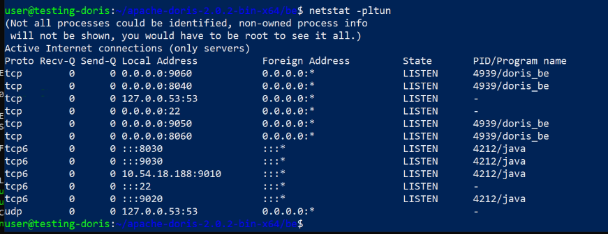
Jika sudah seperti ini tandanny apache doris Sudah berhasil running
Cek di browser dengan Alamat ip:port
UI FE
10.54.18.188:8030
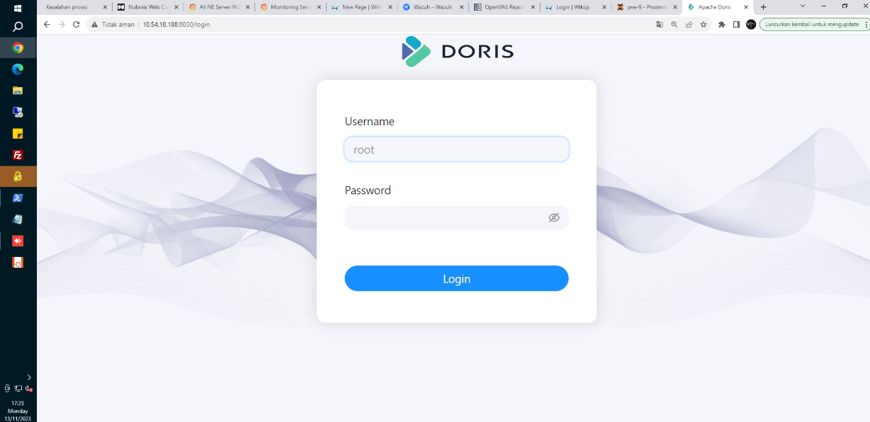
username : root
password : (kosongkan saja)
lalu login
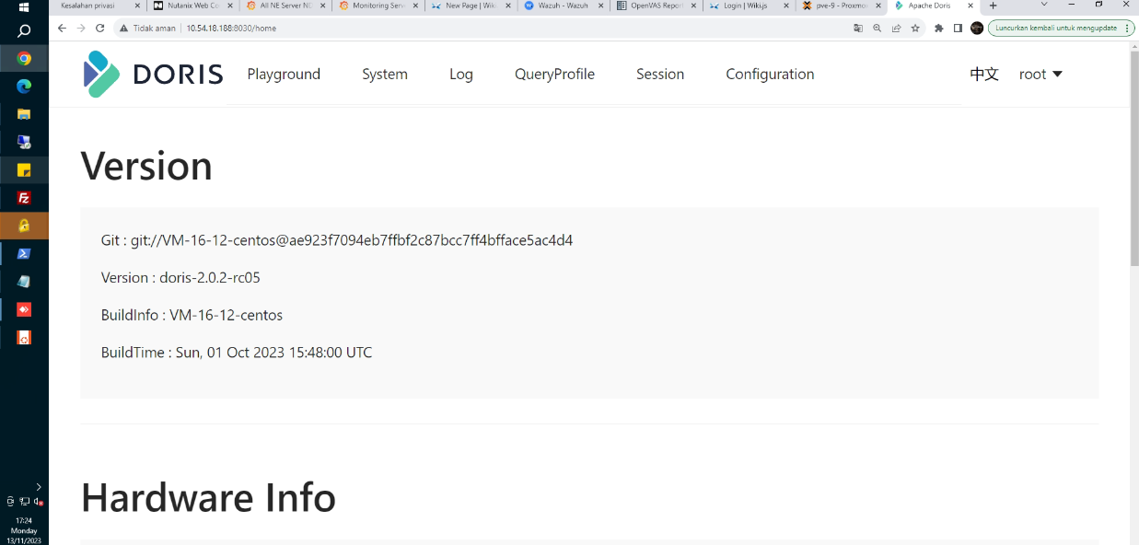
Ini adalah UI fe dari apache doris

UI be
10.54.18.188:8060 / 10.54.18.188:8040
Port 8060
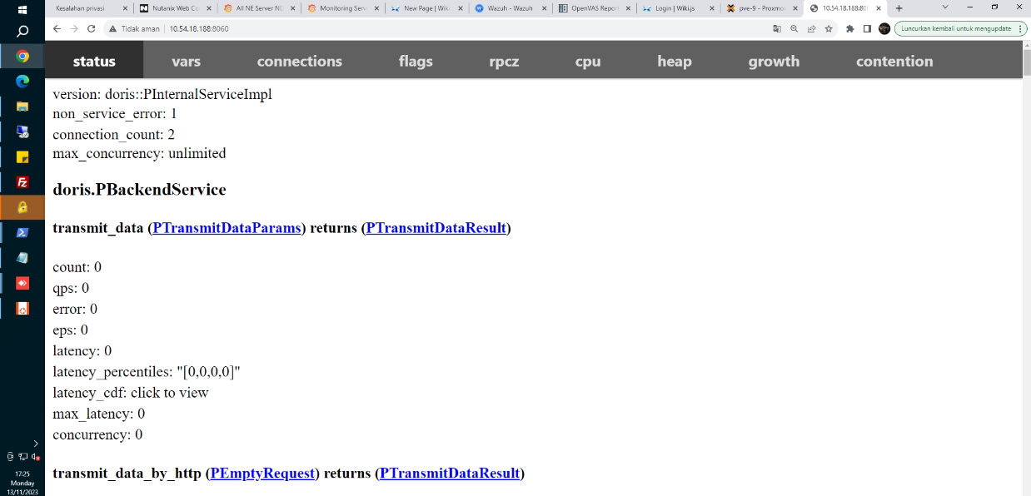
Port 8040
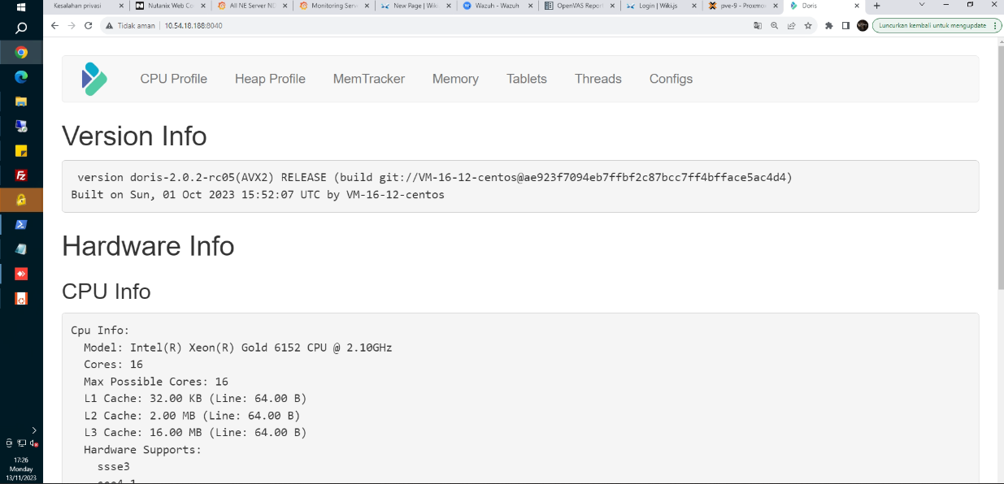

Sekian, Terimakasih

